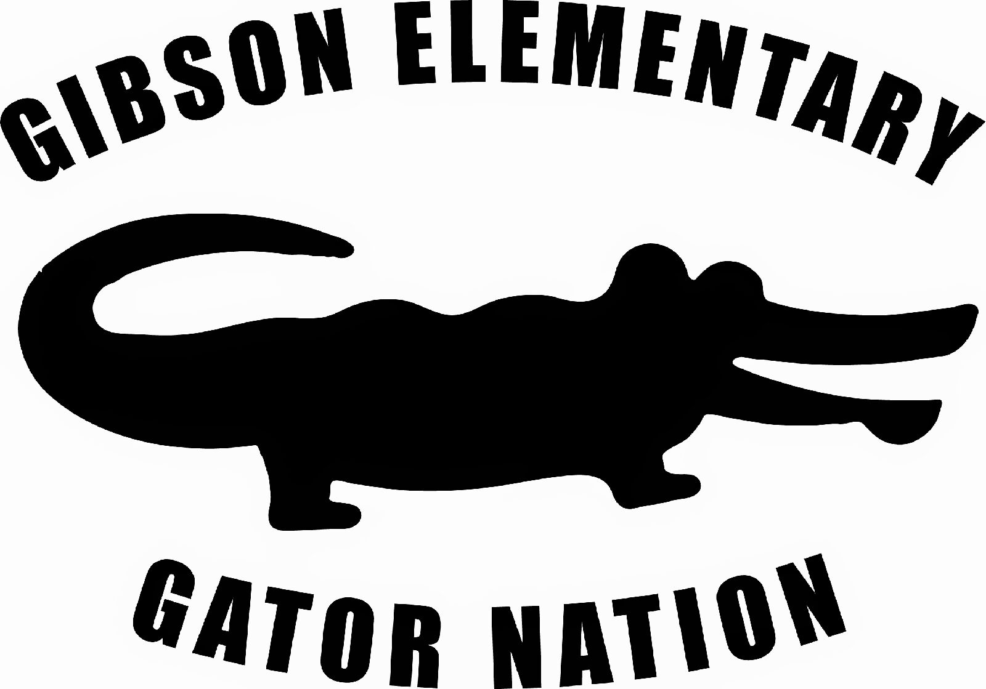
Gibson Elementary PTA
Join Today!

Please support the Gibson Elementary PTA today by joining our PTA membership! The cost is only $10 which goes towards programs for the students, teacher appreciation and much more!

Your membership alone will give us a BIGGER voice in our school and community! Budget, programs, school events and volunteer opportunities will be discussed at monthly meetings (attendance is not mandatory).
We would love for you to join us our next meeting and see all the awesome things Gibson PTA has to offer!!!

Keep in mind that anyone can join the PTA; parents, grandparents, aunts, uncles, high school brothers and sisters, etc.
Any one that has an interest in making our child’s potential a reality can join the PTA and make it possible.
Please contact us at gibsongatorpta@gmail.com or like us on Facebook for information.

Upcoming events and fundraiser:
September 9th – Open house / Jamba Juice Fundraiser September 15th – PTA meeting at Gibson 6pm
September 25th – Pizza Guys Food night 12am to 9pm October 17th – Gibson Fall Festival
October to December – Gibson Musical Theatre (Details TBA)
Box Tops and Campbell’s Education labels we collect all year!
Sign Up for Raley’s, Bel Air and update Quality Cards
Nugget Market Script Cards

Yes, I would like to join the Gibson Elementary PTA!
Number of membership:_______ (Membership is $10 per person)

Name (please print): _____________________ __________

Address: ____________________________________________________

Phone numbers: Home: ______ __________ Cell: _________

Email: ____ _____ _________________________

Student’s Name: ____ __________ Grade: ___ _

Teacher: ____ __________

I am interested volunteering in school events

PTA meetings are on every third Monday on each month at Gibson Elementary 6pm.

